ST. XAVIER’S COLLEGE

**(Affiliated to Tribhuvan University)**

Maitighar, Kathmandu



**DBMS Lab Report #7**

**Submitted by:**

Pankaj Niroula  
013BSCCSIT025

**Submitted to:**

|  |  |
| --- | --- |
| Er. Sanjay K. Yadav  Lecturer Department of Computer Science |  |

**Date of Submission: September 25, 2015**

**Find the eno, ename of the employee whose salary is greater than 4000.**



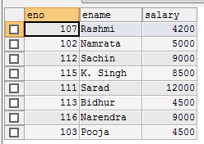

**Find the eno, ename, salary of the employees whose salary is greater than 5000 and job status is professor.**



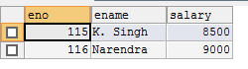

**select address from employee**



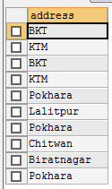

**Distinct**



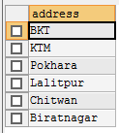

**Find the eno, ename, salary of the employee whose department no. is 20 or jobstatus research fellow.**



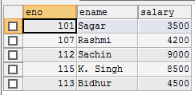

Find the eno, ename age and salary from the employee where the age is between 24 and 28.



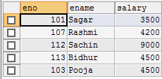

ABC%: All string that start with ‘ABC’. E.g. ABCD and ABCDABCD both will satisfy this condition

%XYZ: All string that end with XYZ. E.g. ZZXYZ

%AN%: All string that contain the pattern AN anywhere

**Find eno, ename whose starting letters are SA.**



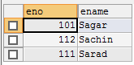

**List all employee names with their project name.**

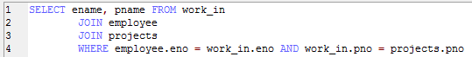

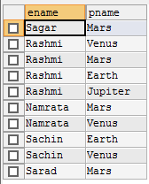

**List all employee names and their salary who are working in project Mars or Venus.**

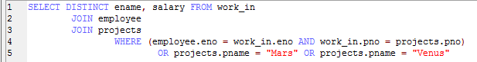

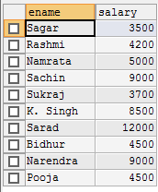

**List name of all employee and their salaries who are working on project Earth and Venus.**

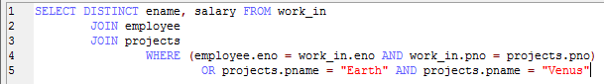

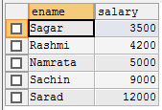

**List name and address of all employee who works in department which is located in Pokhara.**



